Meta Data (SEO & GEO Optimized)
- Blog Title: NIOS Admission 2026: April vs. October Exam Dates, Fees & Status (Official Guide)
- Meta Description: Confused between NIOS April and October 2026 exams? Check the official comparison table, admission deadlines, fee structure, and eligibility rules here.
- Focus Keywords: NIOS Admission 2026, NIOS Oct 2026 Exam Date, NIOS Fee Structure 2026, NIOS Stream 1 Block 2.
Blog Post: NIOS Admission 2026 (April vs. October Exam)
By Unnati Educations | Source: Official NIOS Prospectus 2025-26 | Status: October 2026 Cycle is OPEN
NIOS Admission 2026: Last Date, Fees & Block-Wise Schedule
Introduction
If you are planning to take admission in NIOS Class 10 or Class 12 for the 2026 exam, knowing the exact last date, late fee structure, and exam eligibility is critical. Every year, students miss their preferred exam cycle simply because they misunderstand Block 1 vs Block 2 admissions.
This guide explains NIOS Admission Last Date 2026 in simple language—covering important dates, fees, eligibility, documents, streams, and common mistakes—so you don’t lose a year.
Key Takeaways
- NIOS admissions are 100% online
- There are two main admission blocks every year
- Late fees apply after the normal deadline
- Exam attempt depends on when you take admission
- No upper age limit for NIOS admission

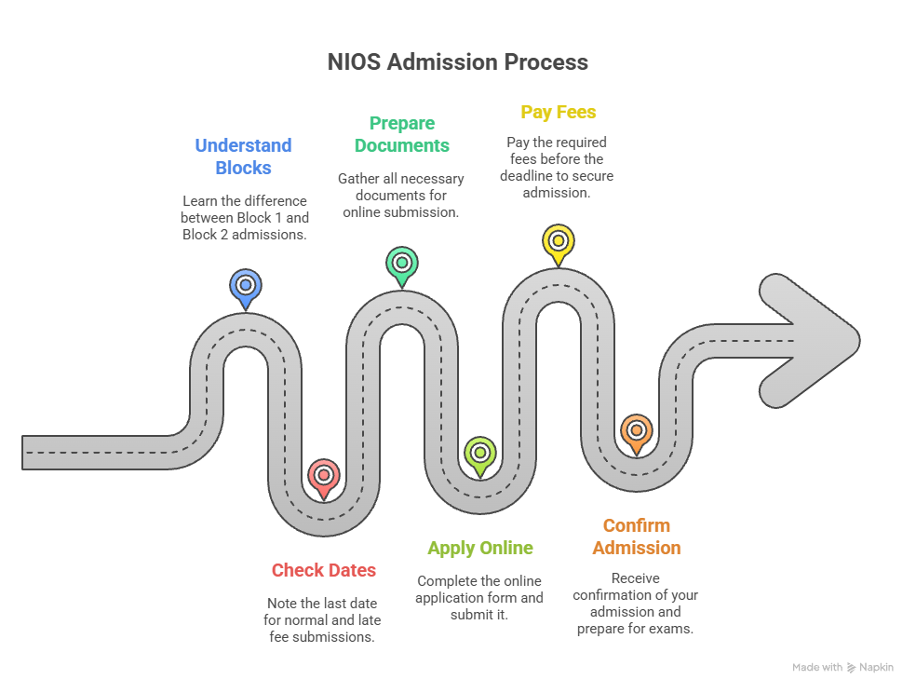
Table of Contents
- What is NIOS?
- NIOS Admission Last Date 2026 (Block-wise)
- NIOS Admission Blocks Explained
- Late Fee Structure
- Eligibility Criteria (Class 10 & 12)
- Documents Required
- Step-by-Step Admission Process
- Which Exam Can You Appear In?
- Common Mistakes to Avoid
- FAQs on NIOS Admission 2026

NIOS Admission Last Date 2026 (Official Schedule)
📅 Block-wise Admission Dates
Admission Block | Without Late Fee | With Late Fee | Eligible Exam
Block 1 | 16 March – 31 July 2025 | Up to 15 Sept 2025 | March–April 2026
Block 2 | 16 Sept 2025 – 31 Jan 2026 | Up to 15 March 2026 | Sept–Oct 2026

Important: Missing Block 1 means you automatically shift to the September–October 2026 exam, not March 2026.
Quick Comparison: April 2026 vs. October 2026
This table is designed for a quick overview. Check which cycle applies to you.
Feature | Stream 1 Block 1 (April Exam) | Stream 1 Block 2 (October Exam)
Exam Month | April 2026 | October / November 2026
Admission Status | CLOSED ❌ | OPEN NOW ✅
Admission Window | Mar 16 – July 31, 2025 | Sept 16, 2025 – Jan 31, 2026
Who Should Apply? | Students who applied early in 2025. | Students wanting to save their year RIGHT NOW.
Result Declaration | June 2026 (Tentative) | December 2026 (Tentative)

Verdict: If you are reading this now, the April 2026 window is closed. You must apply for the October 2026 cycle to get your degree this year
What is NIOS?
The National Institute of Open Schooling (NIOS) is a national-level education board under the Ministry of Education, Government of India. Its certificates are equivalent to CBSE, ICSE, and State Boards and are valid for higher education, government jobs, and competitive exams .
NIOS is ideal for:
- School dropouts
- Working students
- Sports persons
- Repeaters
- Students needing flexible learning

NIOS Admission Blocks Explained
Block 1
- Best for students targeting March–April 2026 exam
- Recommended for fresh admissions
- Longer preparation time

Block 2
- For students who missed Block 1
- Exam held in September–October 2026
- Slightly shorter preparation window

Official Fee Structure (2025-26)
Pay directly online at sdmis.nios.ac.in. Fees are the same for both April and October cycles.
Student Category | Class 10 (Secondary) Fee | Class 12 (Sr. Secondary) Fee
General (Male) | ₹ 2,340 | ₹ 2,600
General (Female) | ₹ 1,890 | ₹ 2,150
SC / ST / PwD / Ex-Service | ₹ 1,560 | ₹ 1,690
Additional Mandatory Charges:
- Registration Fee: ₹ 50 (per application).
- Exam Fee: ₹ 300 per subject (Paid later before exams).
- TOC Fee: ₹ 230 per subject (Only if transferring marks).
Late Fee Structure (Do Not Ignore This)
Period | Late Fee
1–15 days late | ₹260
16–31 days late | ₹520
1–15 days after next window | ₹910

Reality check: Many students delay admission thinking “NIOS is open all year.” Yes, admissions are open—but your exam cycle suffers.

Eligibility Criteria for NIOS Admission 2026
Ensure you meet these criteria before paying fees.
Criteria | Class 10 (Secondary) | Class 12 (Senior Secondary)
Minimum Age | 14 Years (as of 31st Jan 2026) | 15 Years (as of 31st Jan 2026)
Education | Class 8 Certificate OR Self Certificate | Class 10 Pass Marksheet (Mandatory)
Valid Proof | Aadhaar Card / Birth Certificate | Class 10 Certificate
Gap Year Rule | N/A | Must have 2 Years Gap between Class 10 & 12 passing year.
(Source: NIOS Academic Prospectus 2025–26)

Documents Required (Ready-to-Scan List)
Keep these files ready in JPG/PNG format on your phone/laptop.
Document Name | Why is it needed?
Recent Photo | For Identity Card.
Signature (Black Ink) | For Official Records.
Aadhaar / Passport | Proof of Identity & Address.
Class 10 Marksheet | Mandatory for Class 12 Admission.
Category Certificate | Required only if you want SC/ST Fee Discount.
Failed Marksheet | Required ONLY if applying for TOC (Transfer of Credit).

Step-by-Step Admission Process
- Visit Portal: Go to the official website sdmis.nios.ac.in.
- Register: Click on "Stream 1 (Block 2)" and verify your mobile number.
- Fill Details: Enter basic details, address, and select your Study Centre (AI) carefully.
- Choose Subjects: Select minimum 5 subjects. (Use TOC if applicable).
- Upload Docs: Upload the scanned documents from the checklist above.
- Payment: Pay the fee online via UPI/Card.
- Print: Download the ID Card generated after verification.

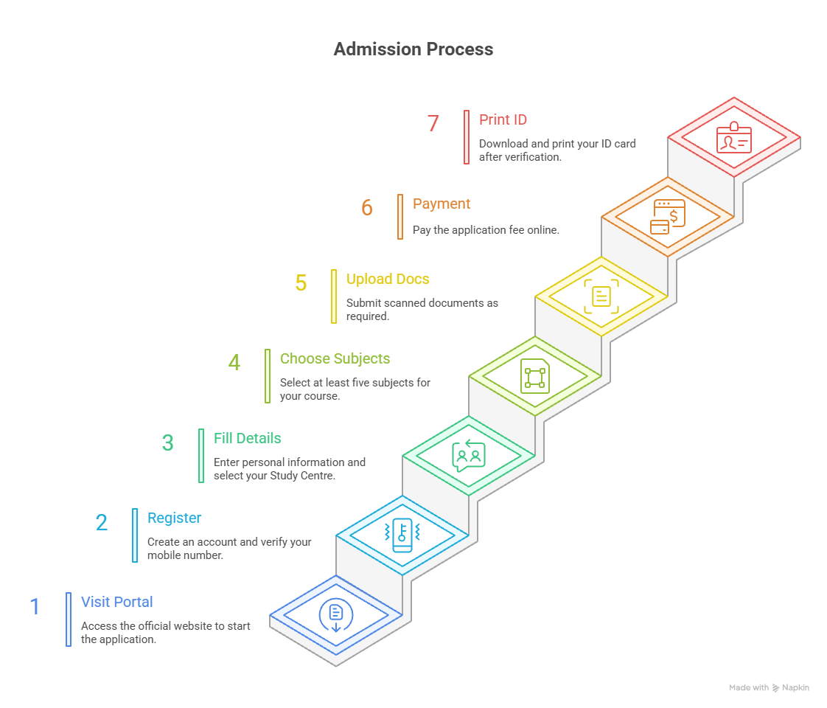

[EMBED YOUTUBE VIDEO HERE: "How to Fill NIOS Admission Form Step-by-Step"]
Which Exam Will You Appear In?
This depends only on your admission block, not on when you start studying.
Admission Block | First Eligible Exam
Block 1 | March–April 2026
Block 2 | September–October 2026

Common Mistakes Students Make
❌ Assuming “late admission won’t affect exams”
❌ Choosing wrong subject combination
❌ Uploading incorrect DOB proof
❌ Missing Block 1 due to overthinking

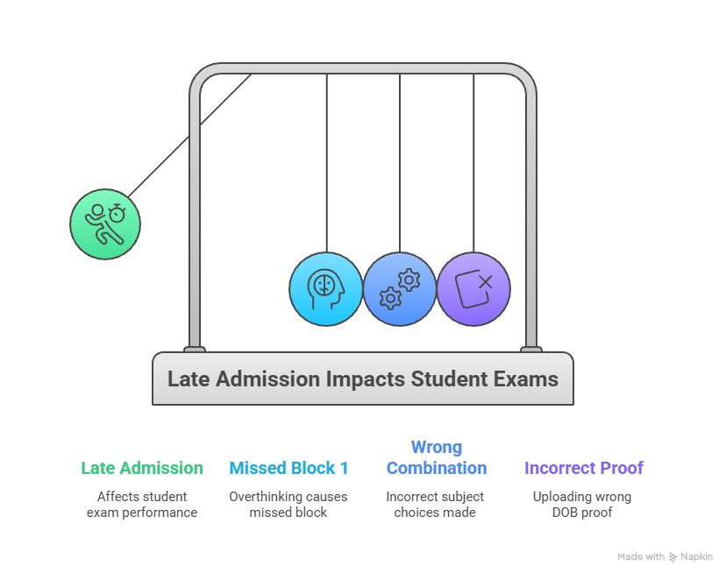
FAQs – NIOS Admission Last Date 2026
- Is NIOS admission open throughout the year?
Yes, but exam eligibility changes based on admission block.
- Can I take admission after September 2025?
Yes, under Block 2, but your exam will be September–October 2026.
- Is NIOS certificate valid for NEET, CUET, government jobs?
Yes, provided subject eligibility rules are met.
- Can working students apply?
Yes. NIOS is designed for working learners.
- Can I still apply for the April 2026 Exam?
Ans: No. The admission window for April 2026 closed on September 15, 2025. You can now only apply for the October 2026 exam.
- Is the fee refundable if I cancel admission?
Ans: No. The admission fee paid to NIOS is non-refundable under any circumstances.
- How many subjects can I choose?
Ans: You can choose a minimum of 5 subjects and a maximum of 7 subjects. However, to pass, you only need to clear 5 subjects.

Final Advice (Read This Carefully)
If you missed the Block 1 deadline (July 2025), do not wait another year! Apply for Block 2 (October Exam) immediately before 31st January 2026 to save your year
📌 Need Help With NIOS Admission 2026?
Get eligibility check, subject selection guidance, and admission support from experts before making irreversible mistakes.
Last updated as per NIOS Academic Prospectus 2025–26

RAHUL CHECK KER LIYO
Technical SEO Check
- Heading Hierarchy: You have "Block 1" and "Block 2" under "NIOS Admission Blocks Explained". Make sure these are H3 headings (sub-headings), not H2.
- Video Placeholder: You didn't include the video link placeholder in the doc. Don't forget to add: [Embed YouTube Video Here: How to Fill Form] inside the "Step-by-Step" section. This increases the time users spend on the page.

